# HomeWork1 Report

Main file is R2000i.m

## Calculation of DH-parameters

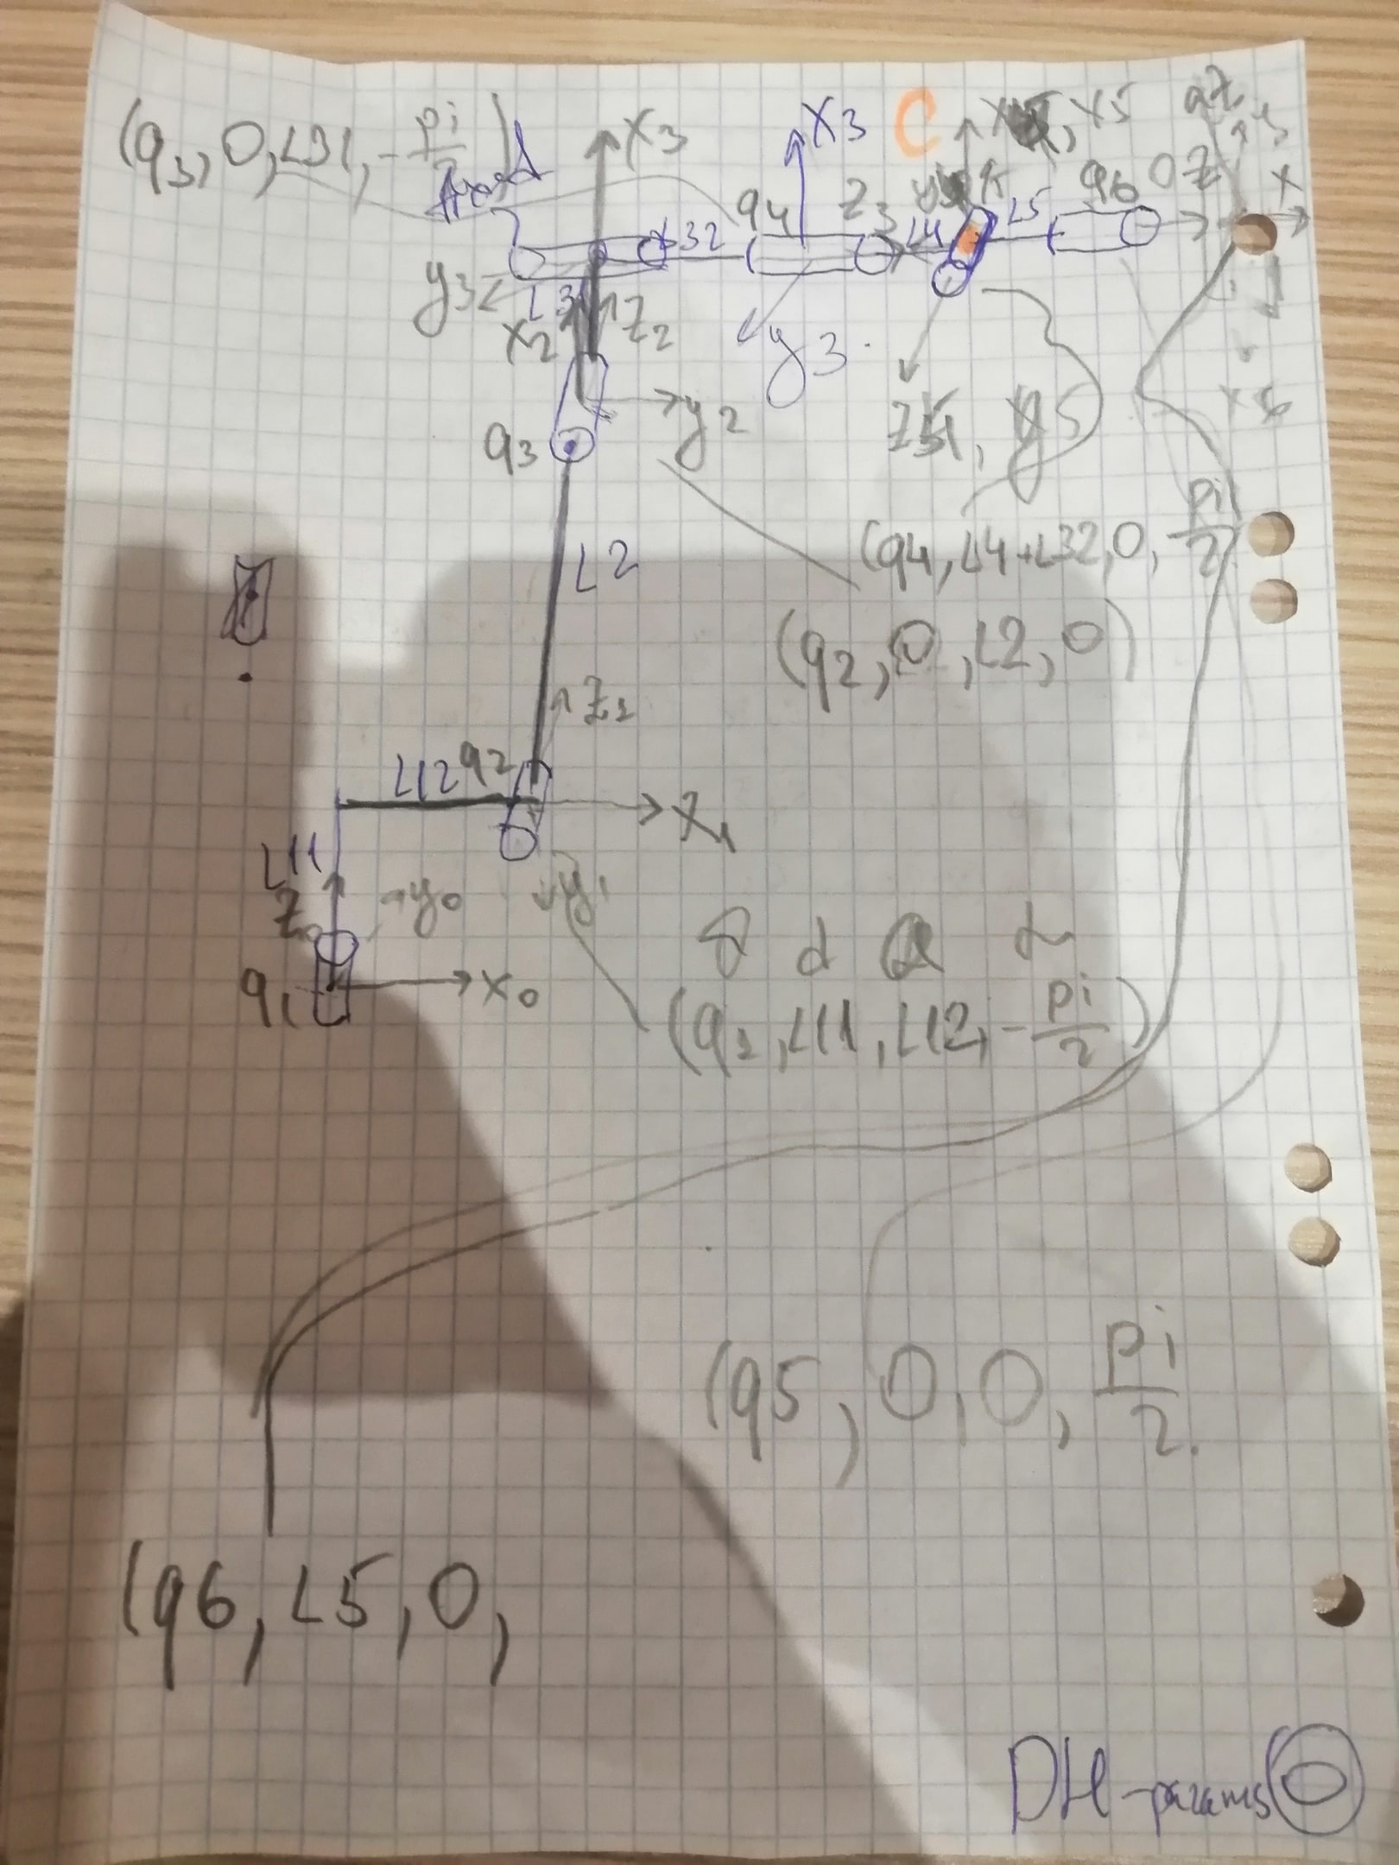

I had to add one additional axis (4th) to plot my model and in order to be able to calculate IK and decouple it. This axis doesn’t rotate. So, below we have 7 axises. Point C(orange) is the point where 3 axis coincide.

## Direct Kinematics

I created DK function that have angles of axis as inputs and T marix (HM) as output.

Algorithm:

1. Enters Configuration, DH-parameters
2. Sets limits
3. If 2 is okay, plot the robot. If 2 isn’t okay, change angles and repeat (F5)
4. Exams the solution by the function of RTbox (fkine)
5. Converts angles from rad to deg
6. Uses function FK (Function calculates the T0_7 matrix)
7. Outputs it

## Inverse Kinematics

I created IK function that have T matrix as input and angles of rotations as outputs.

T matrix can be set by yourself or be taken from DK.

Algorithm:

1. Enters Configuration, DH-parameters
2. Calculates the pos of the tool
3. Sets limits of workspace
4. Calculates thetas (angles)
5. Calculates the HM from 0 to 4
6. Calculates the HM from 4 to 6 (to calculate last 3 rotations)
7. Calculates last 3 thetas from formulas (due to the symbolic view of T5_7)
8. Output all angles
9. Plotting

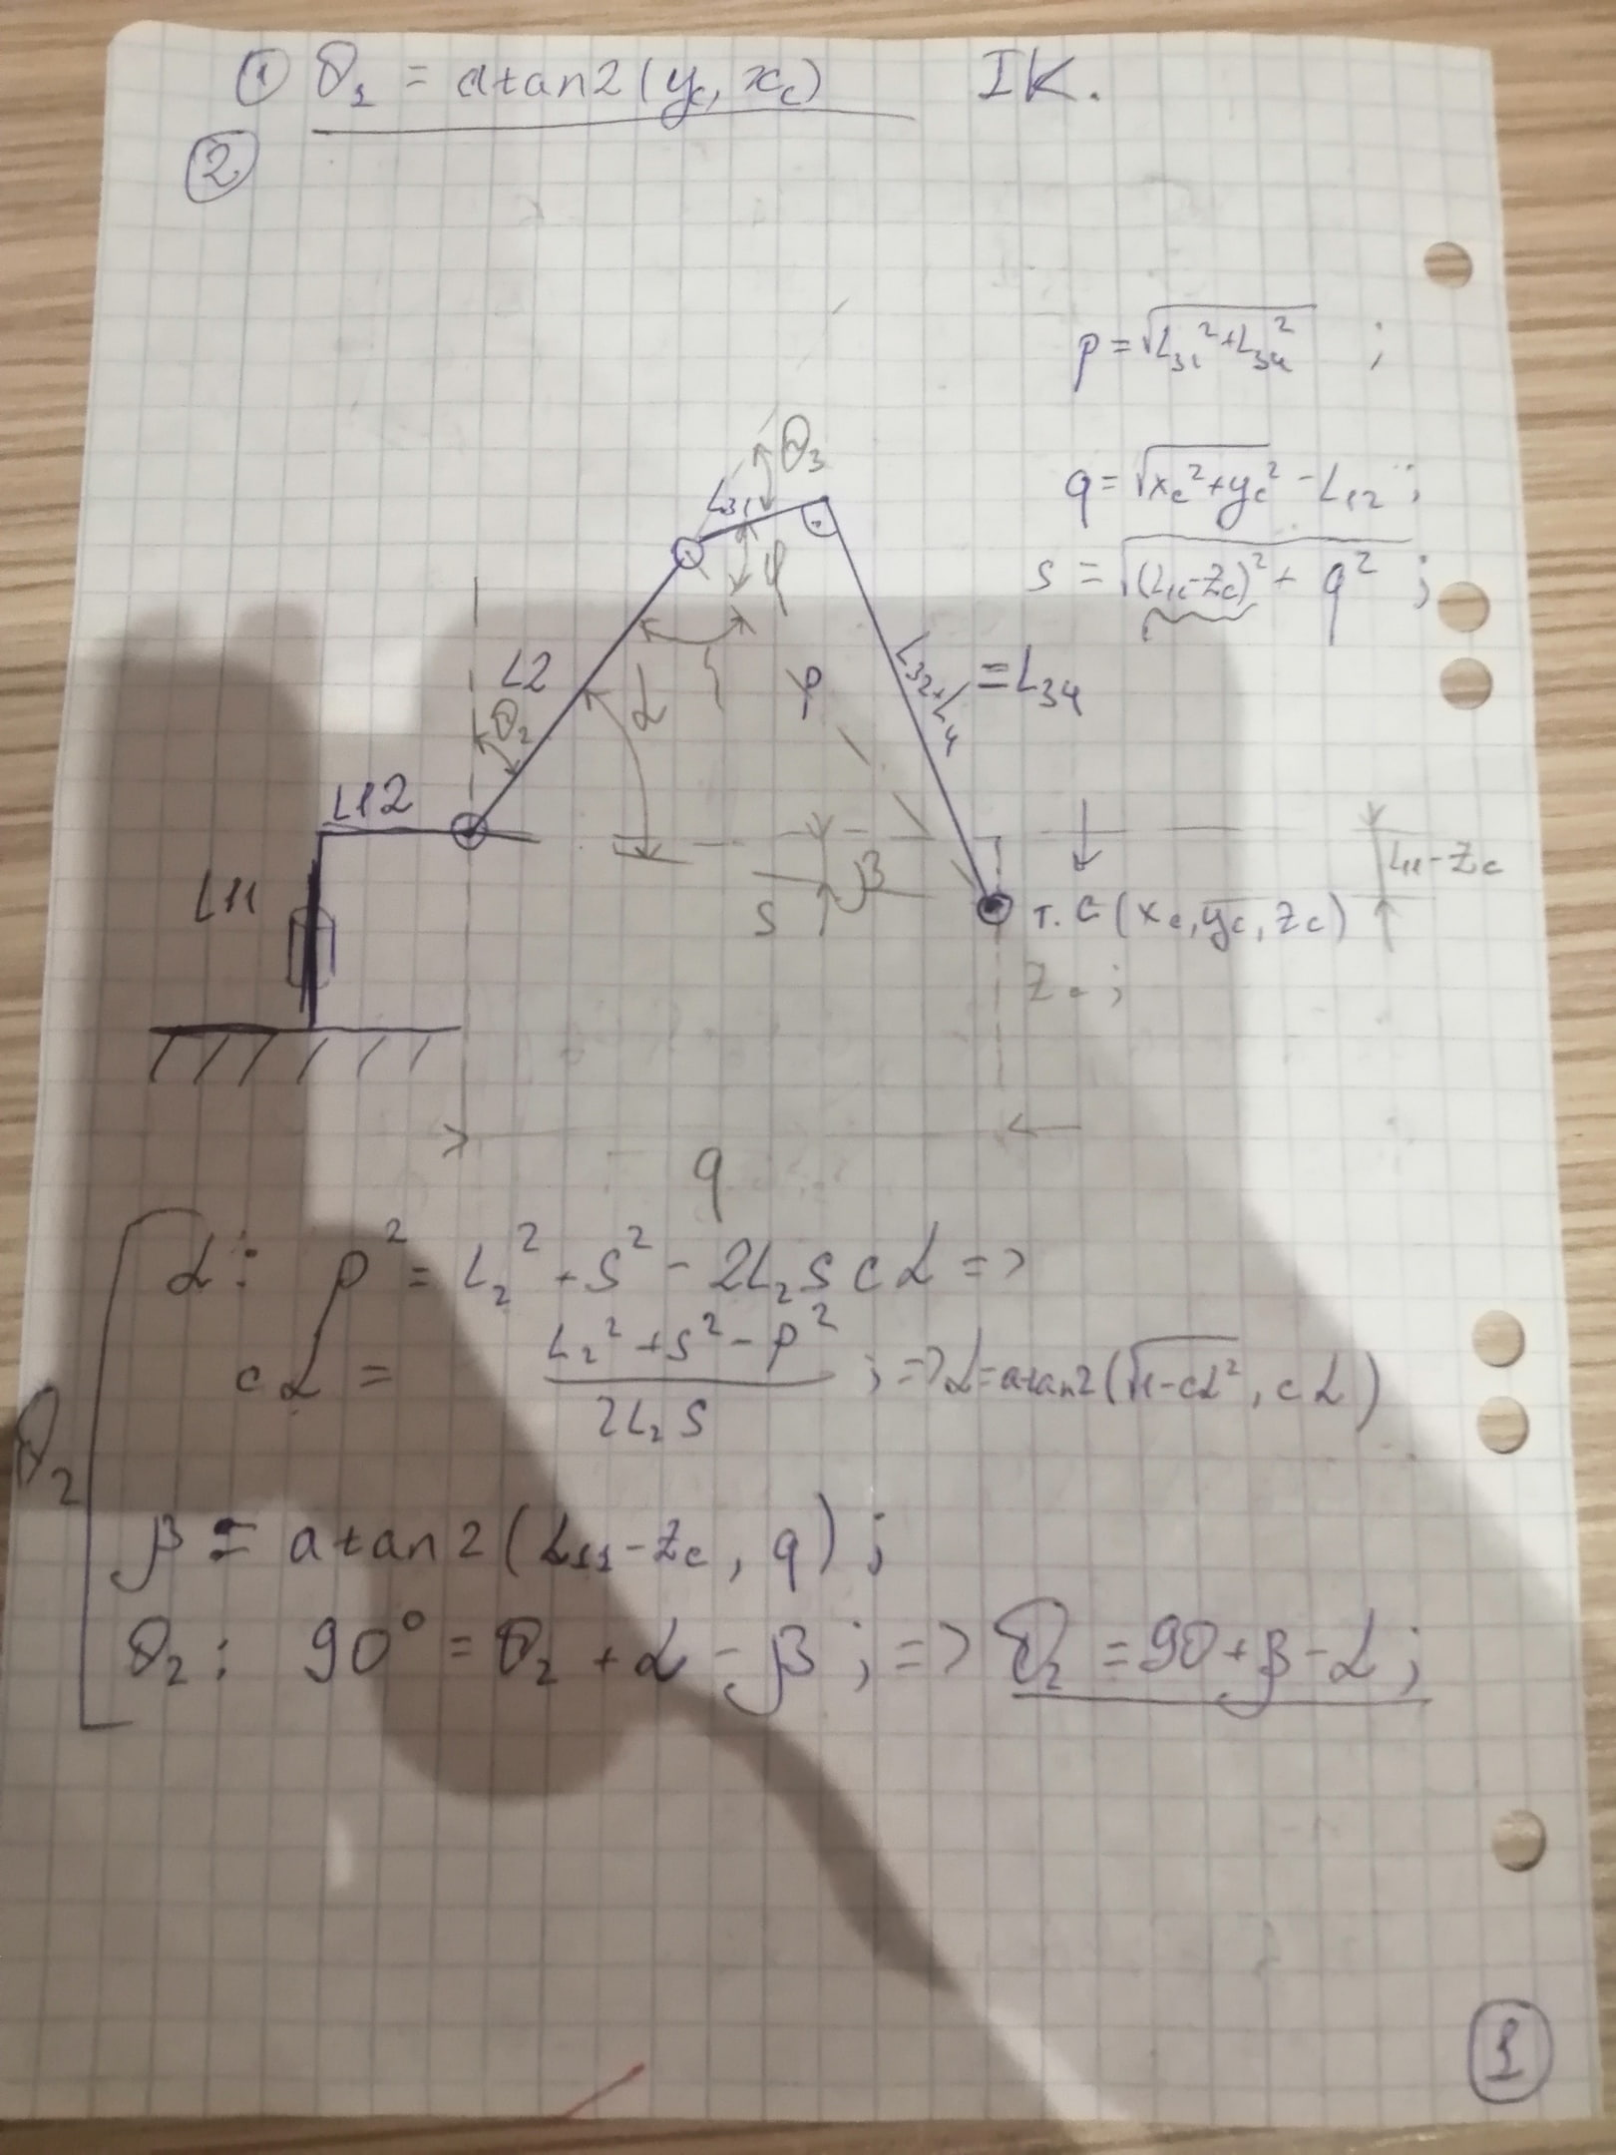

Pic.2 Calculating of theta1 and theta2.

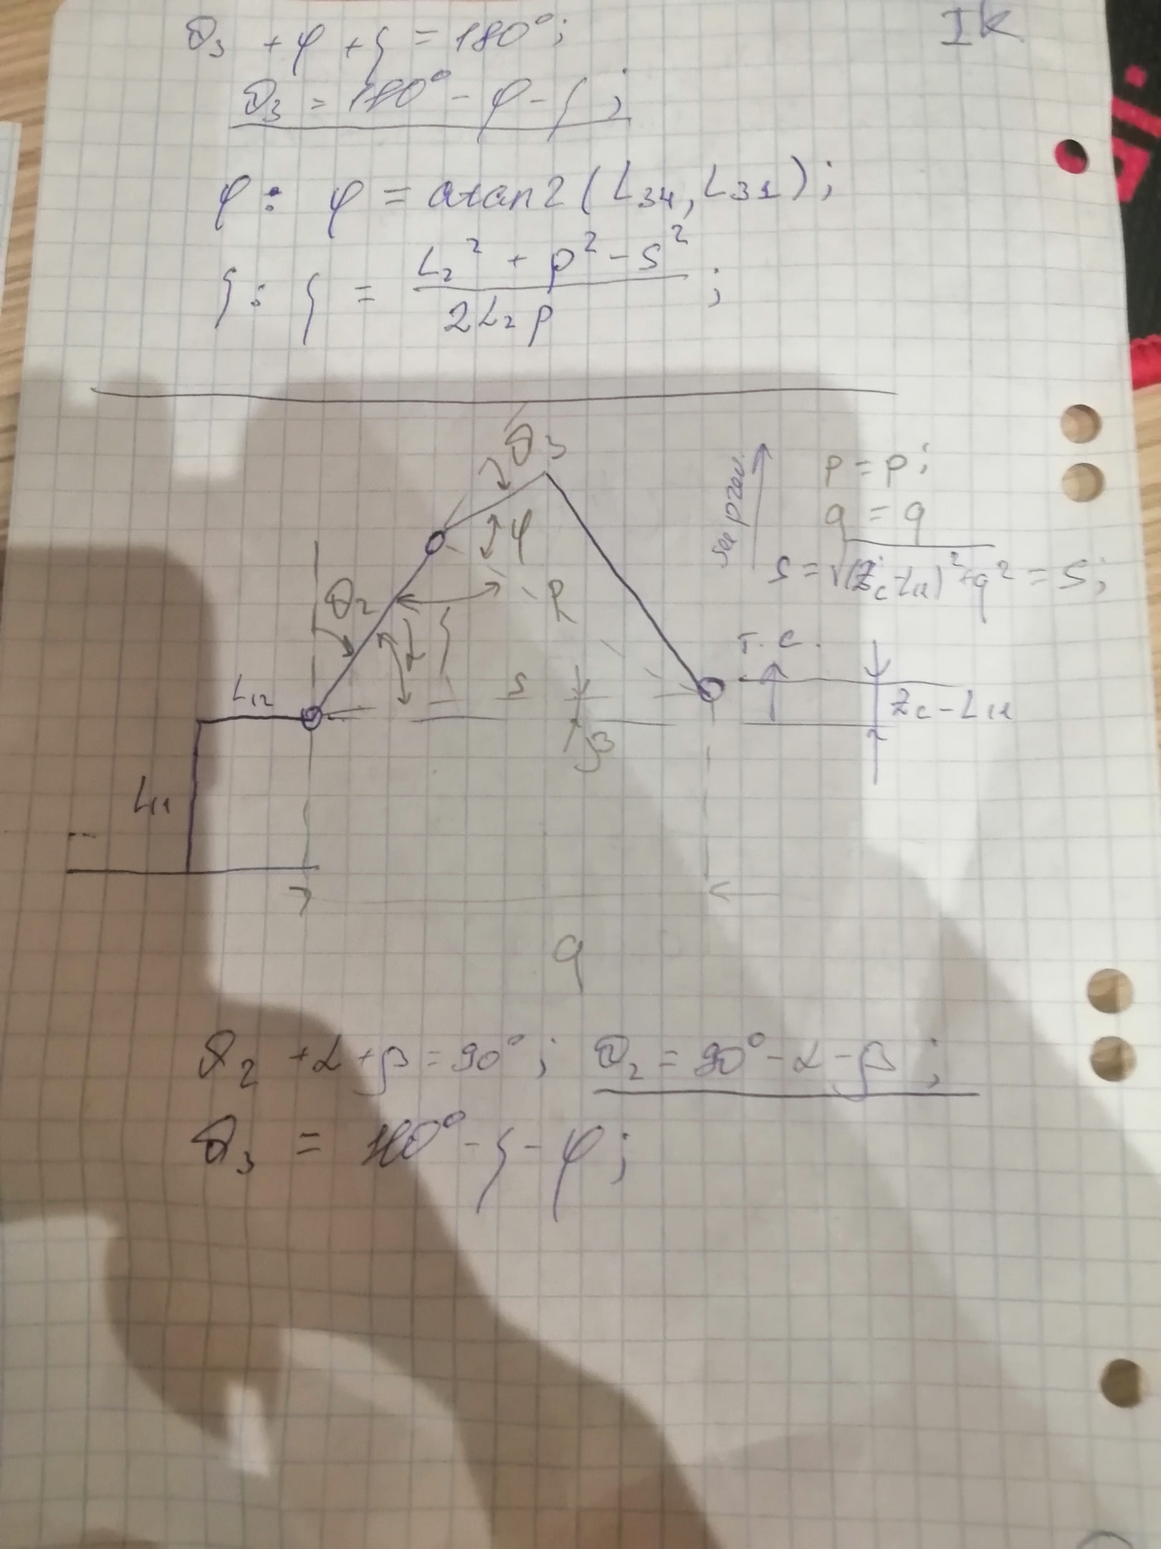

Pic.3 Calculating of theta3

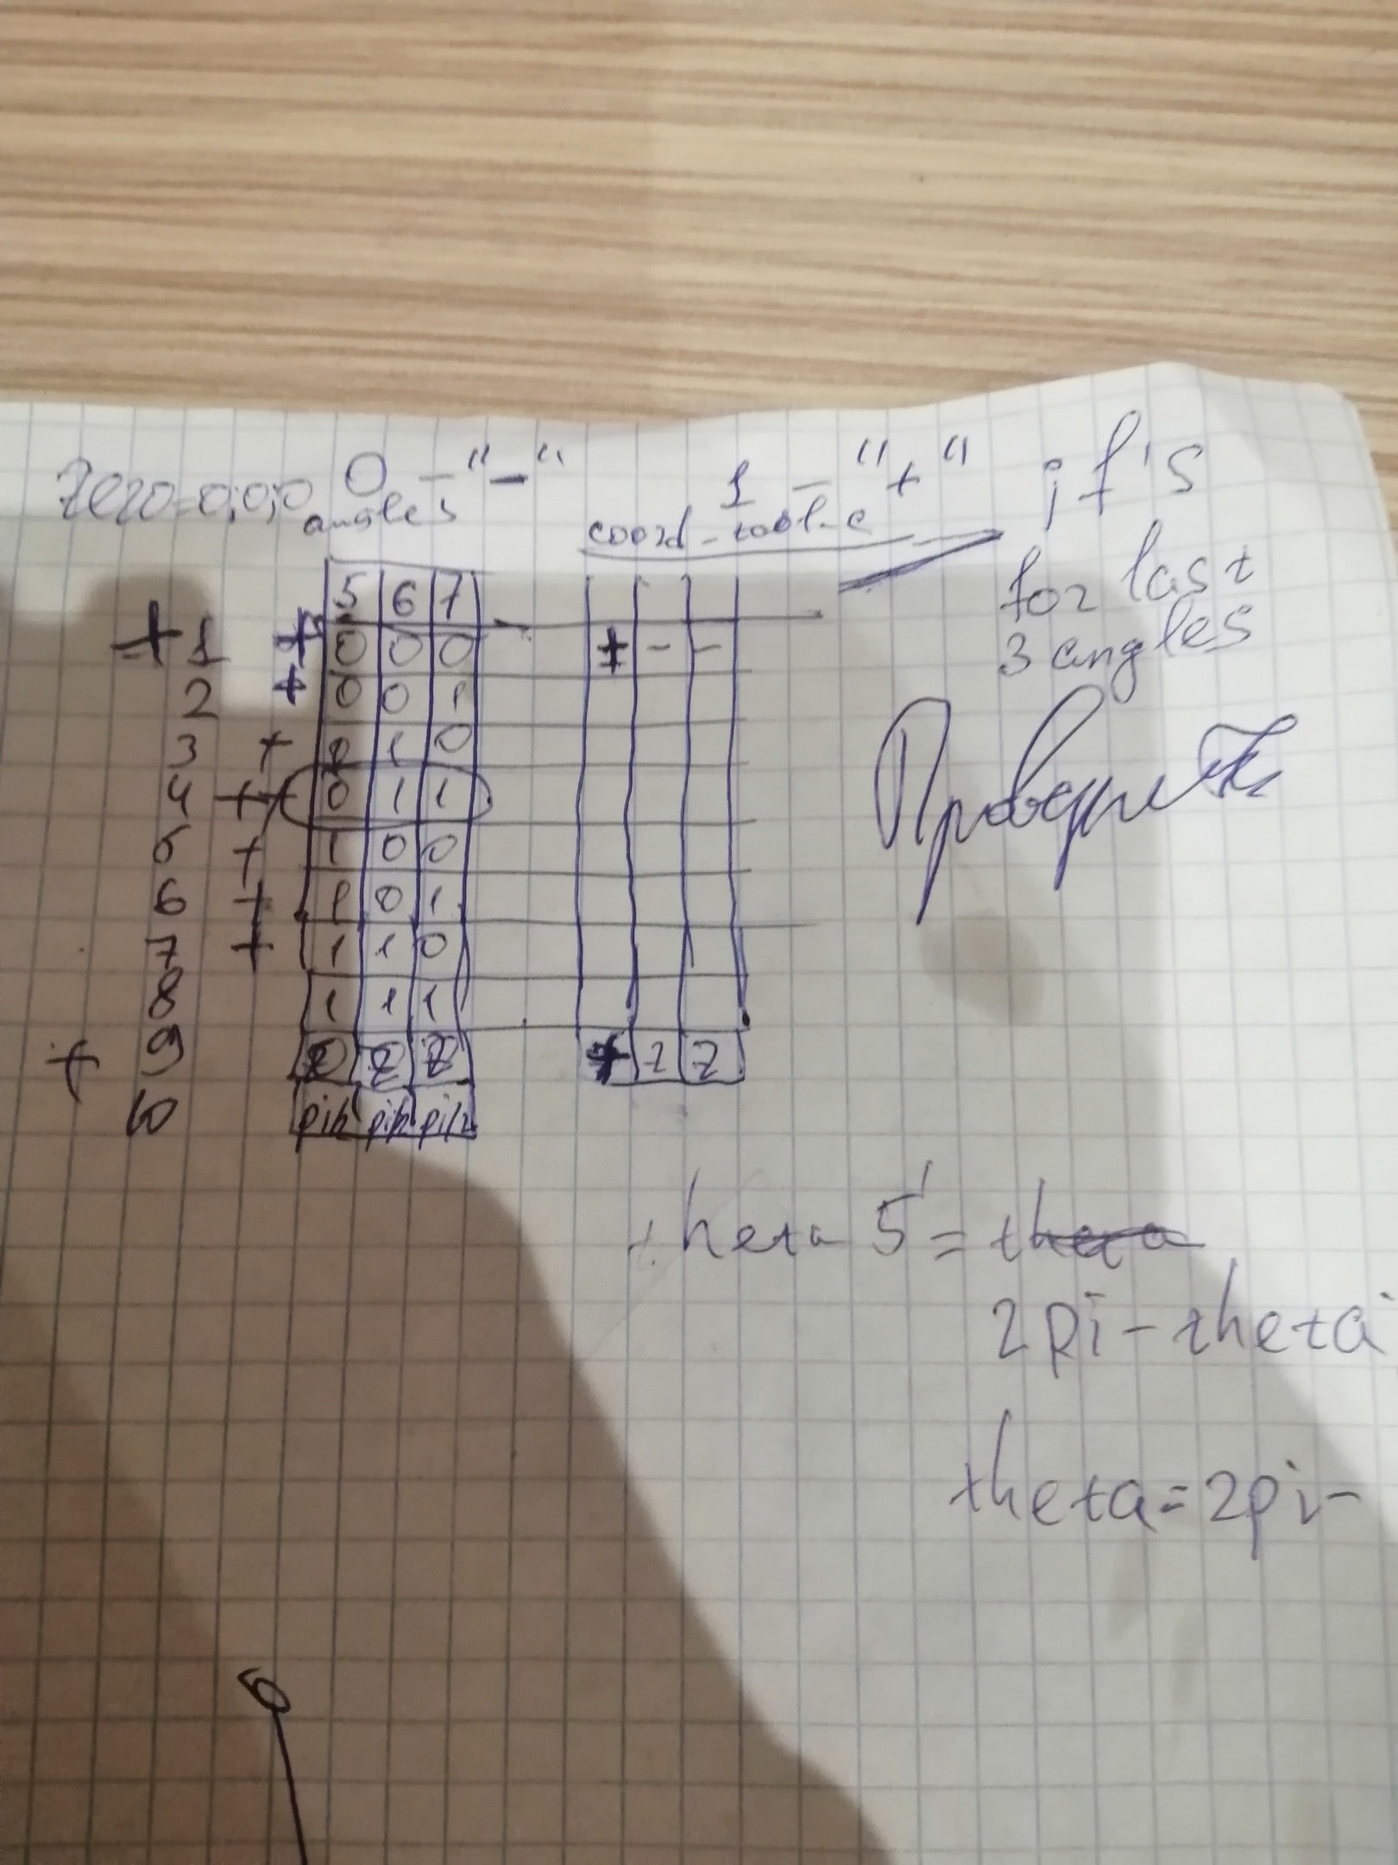

Pic. 4 Numerical method

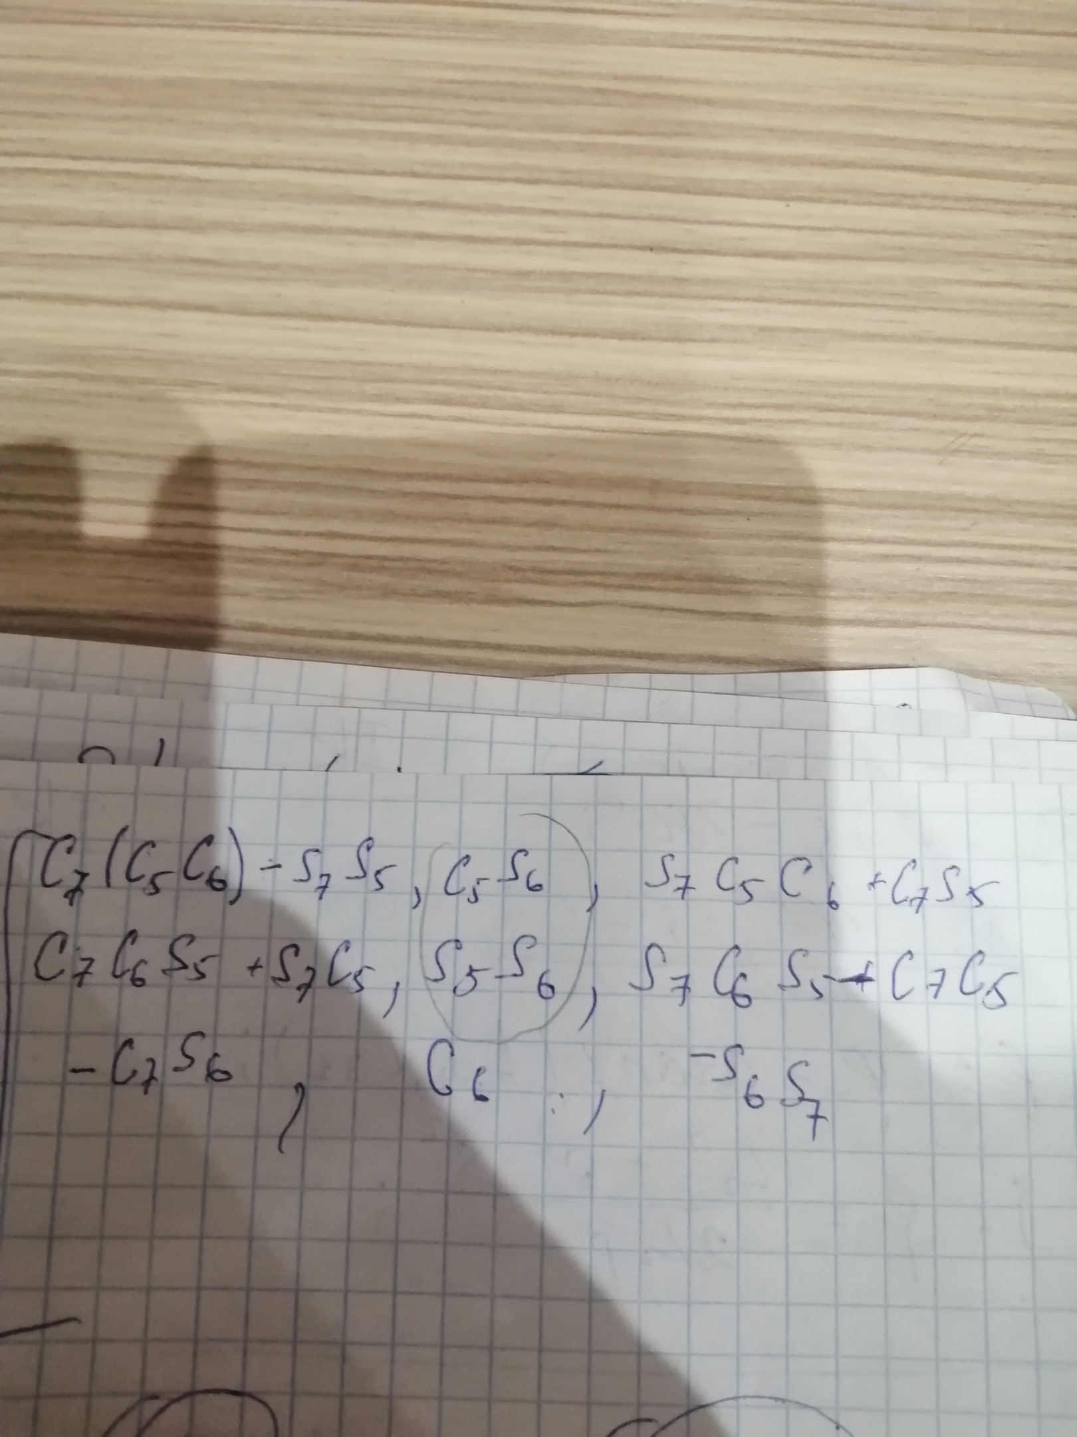

Pic. 5 T5_7 matrix (only R part demonstrated)

## Tests

### Direct Kinematics solution

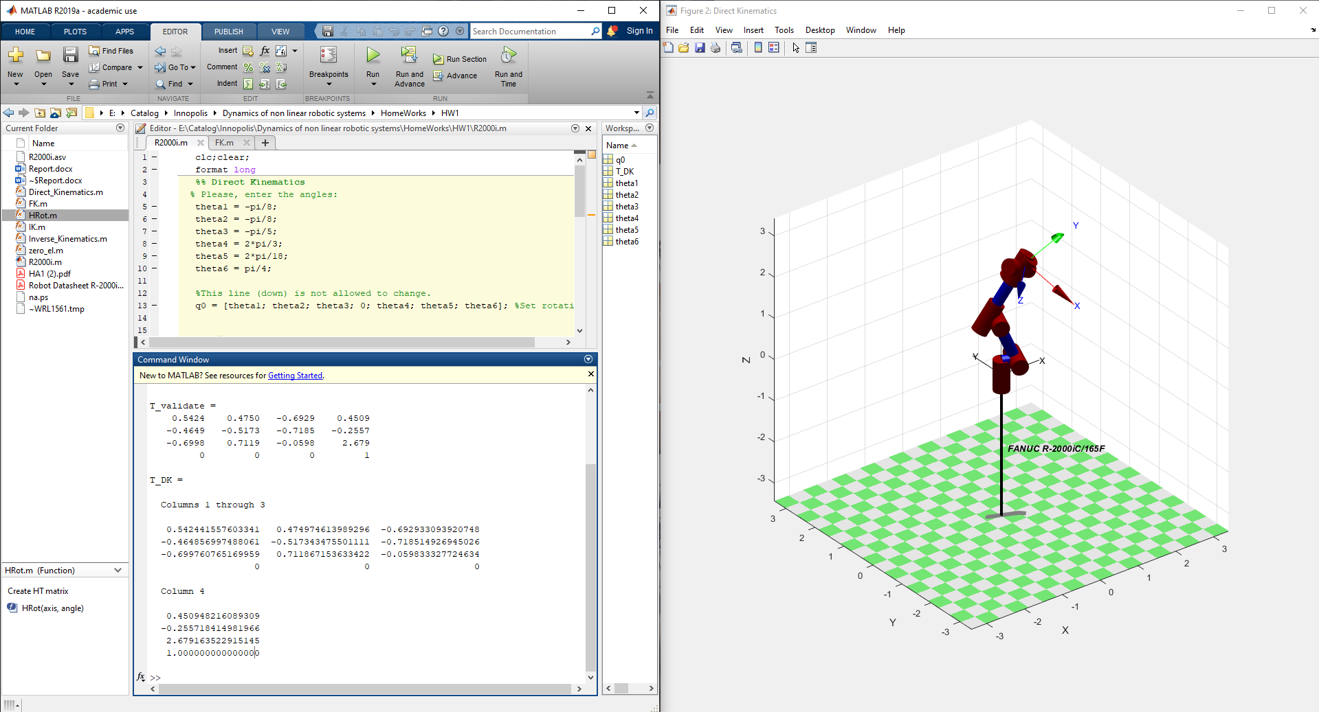

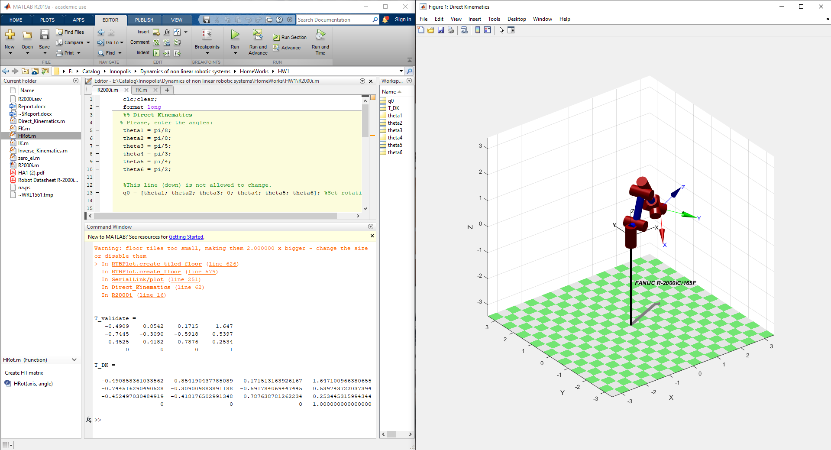

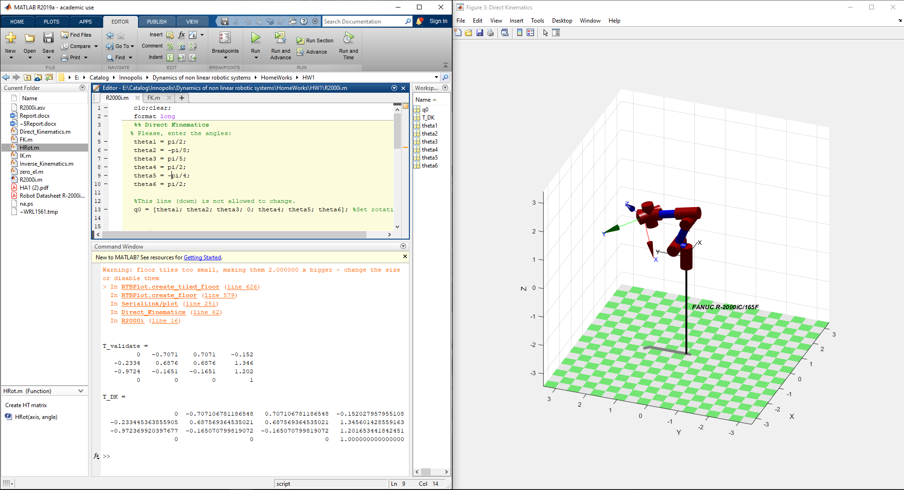

### Inverse Kinematics solution

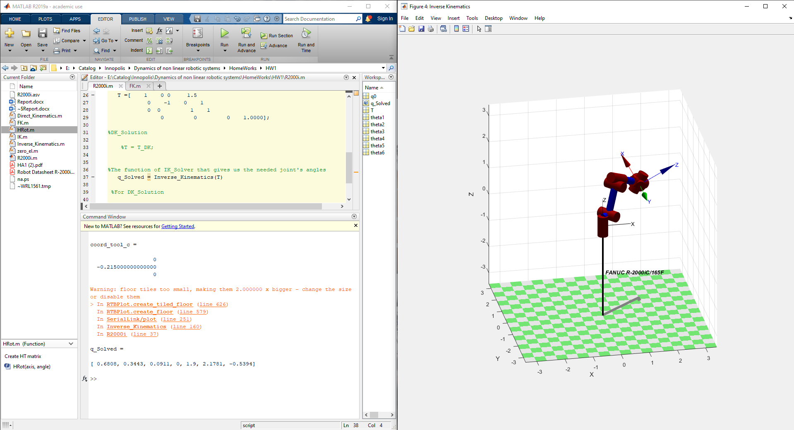

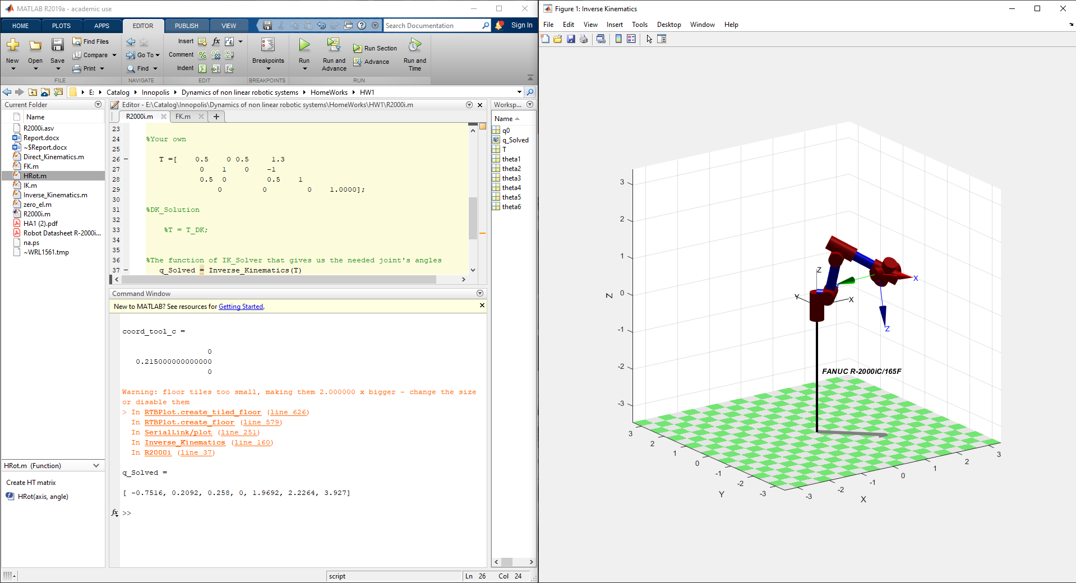

### Direct🡪Inverse Kinematics Solution

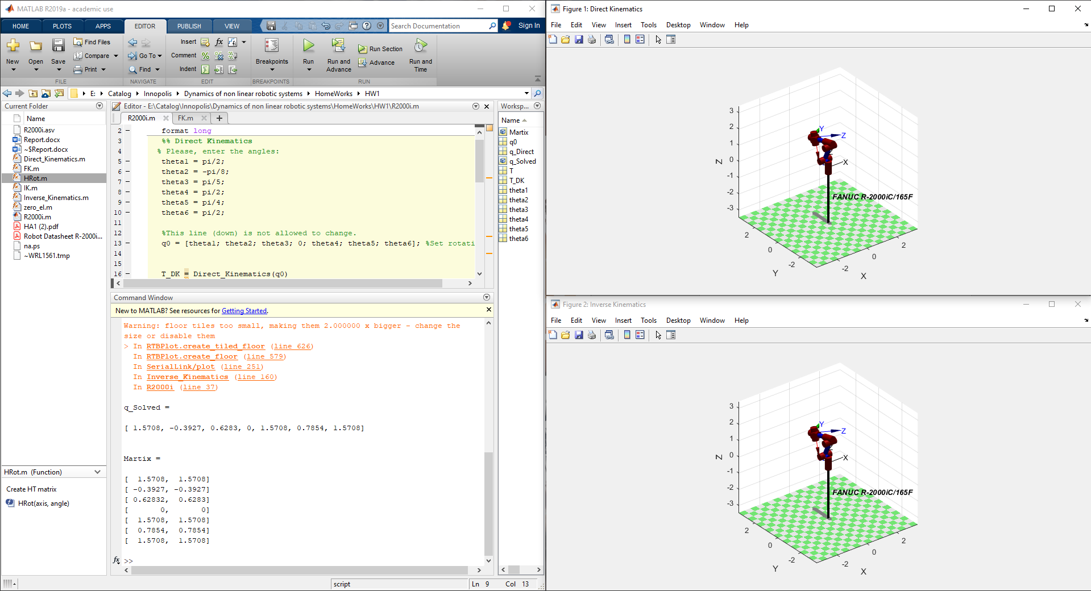

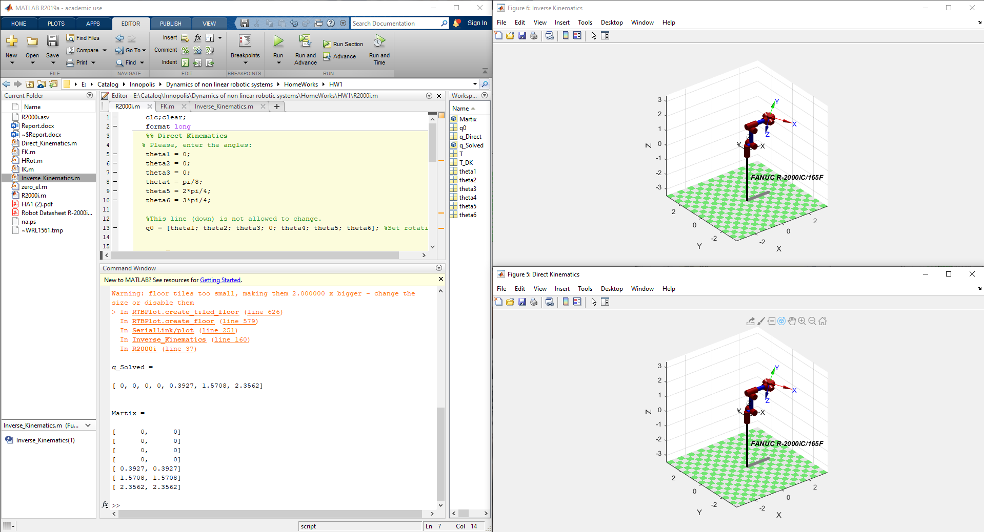

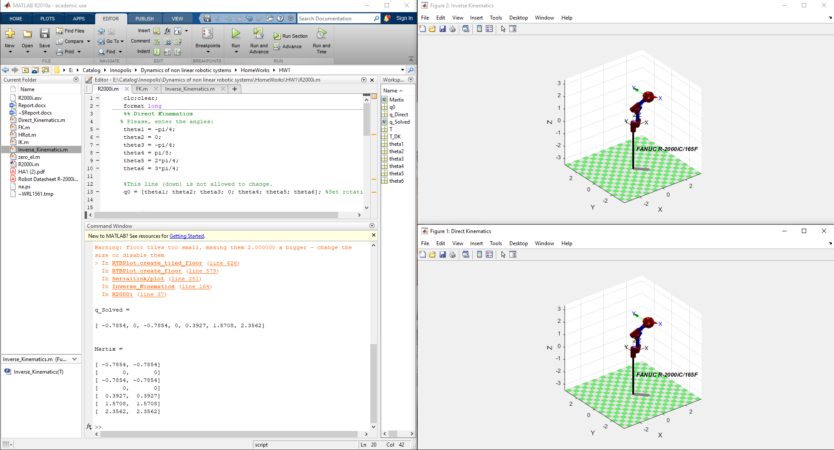

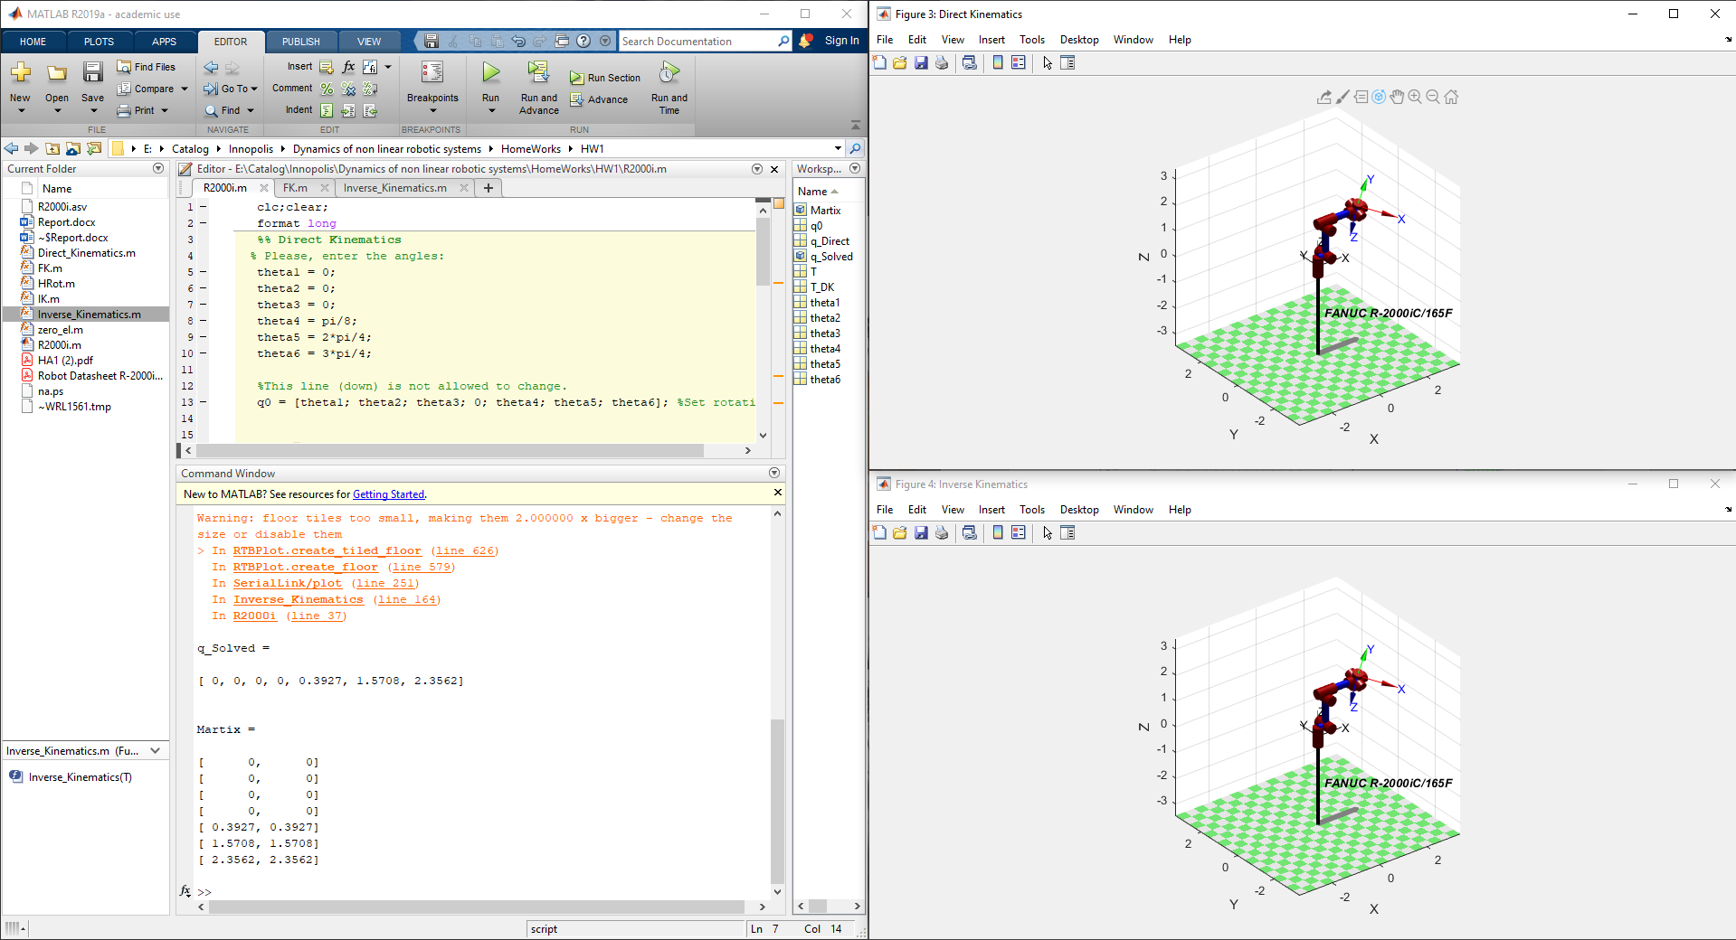

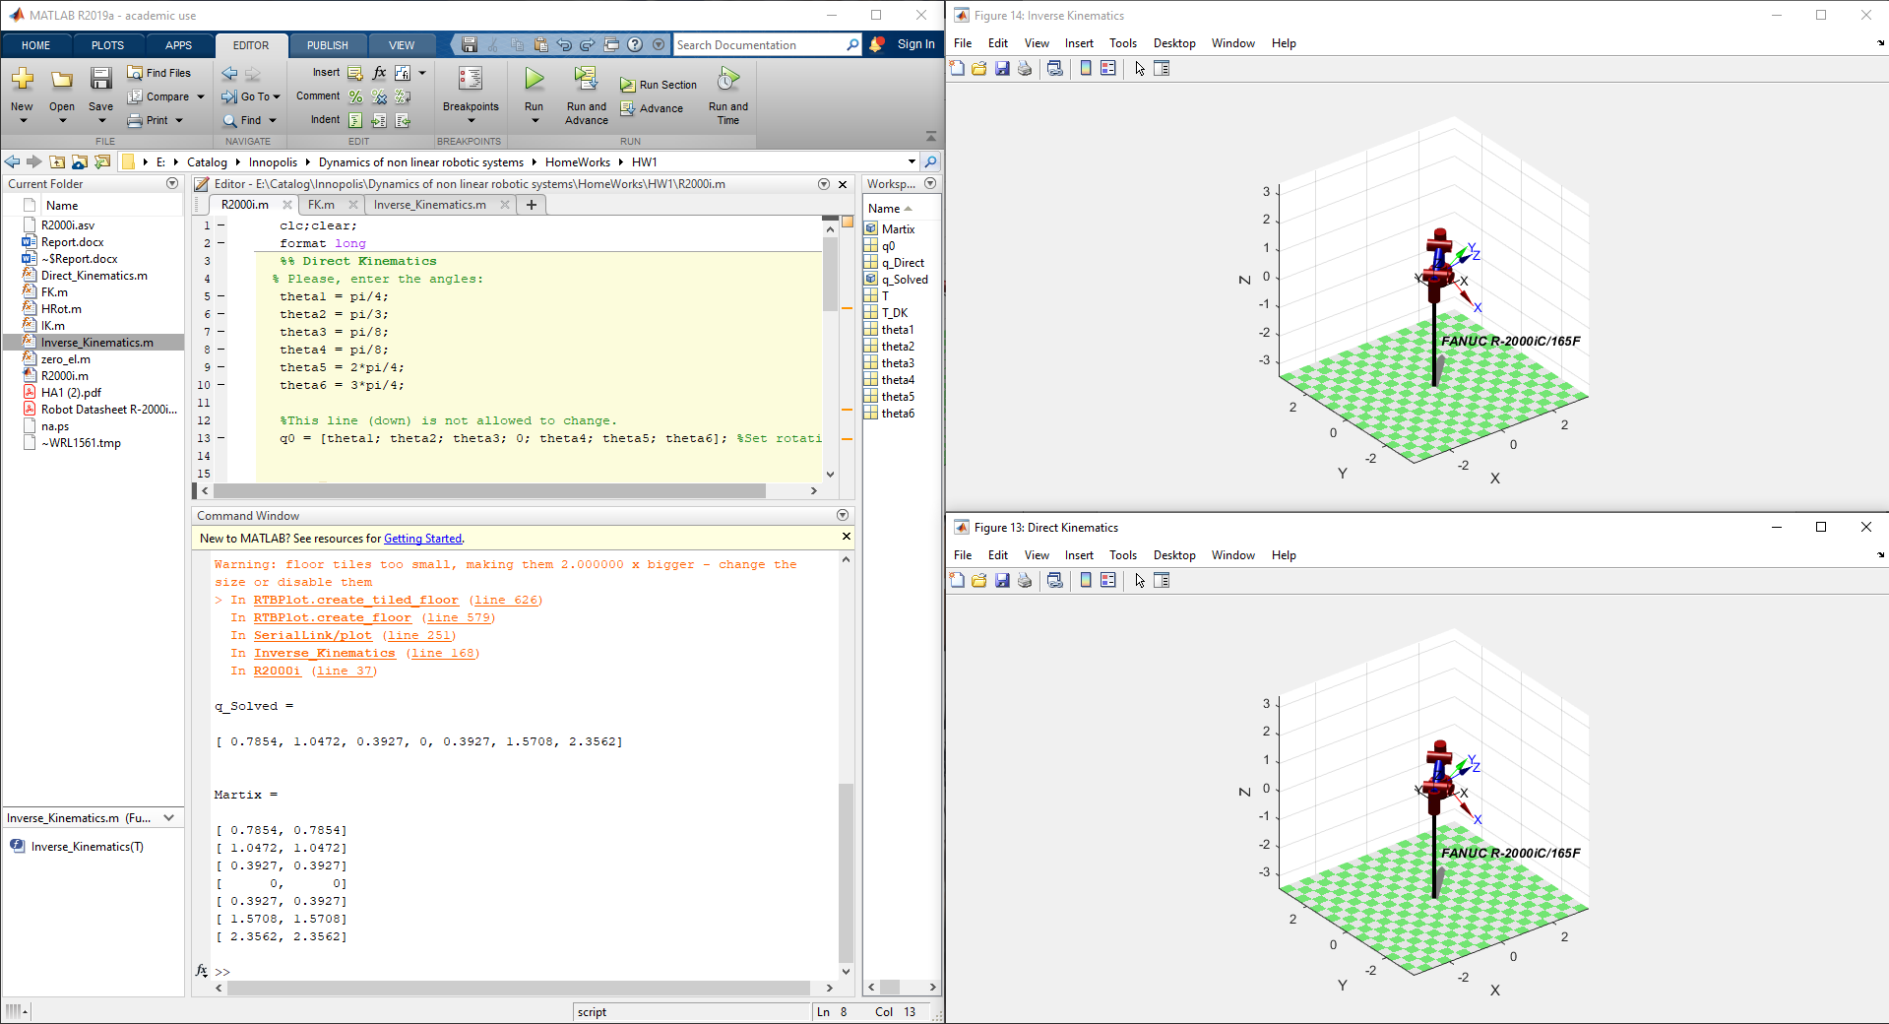

Problem:

